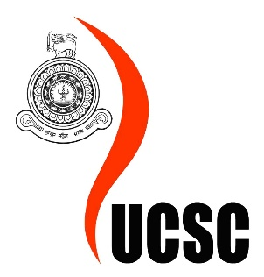
University of Colombo School of Computing
Internal Undergraduate Degrees
Course Detail Document

Course Outline
Course Code : | SCS2111
Course Name : | Laboratory II
(Bold and underline the appropriate) | Year : | 1 | 2 |  | 3 | 4 |  |  |  | Semester : |  | 1 | 2
Number of Credits | 1L + 1P
Core/Optional | core
Evaluation Criteria | Assignments : |  |  | 70%
Evaluation Criteria | Final Exam : |  |  | 30%
Requisites for following the Course
Method of Delivery |  |  |  |  |  |  |  | Per Week |  |  | Total
Method of Delivery | Lectures |  |  |  |  |  |  | 1
Method of Delivery | Tutorials
Method of Delivery | Lab Work |  |  |  |  |  |  | 1
Method of Delivery | Group Work

Course Definition
Introduction | This course is intended to introduce numerical and statistical computation software to students as domain specific programming tools.
Course Aim/Intended Learning Outcomes | Upon completion of this course, students will be able to do the following:  - Perform basic mathematics and simple manipulations with Octave and R  - Perform basic statistical operations with R  - Use Octave and R for basic plotting  - Write and execute scripts in Octave and R  - Use different data analysis techniques in Octave and R  - Understand how to explore and describe various real-life data sets, using R.
Assessment Plan | - Assignment - 30% (2-3 assignments)  - Paper - 70%
References/Reading Materials

Course Content
- R introduction
  - Introduction to R environment, Getting help, R commands, R scripting and executing
  - Simple manipulations: objects, vectors, vector arithmetic, arrays and matrices, lists and data frames
  - Reading data from file
- R as a Statistical Package
  - Descriptive Statistics: Graphical procedures for Qualitative and Quantitative data, Numerical measures.
  - Estimation and testing hypothesis
  - Simple linear regression and correlation
  - Multivariate data display, Cluster Analysis: K means clustering, K nearest neighbours clustering
- Octave
  - Manipulating variables, data structures
  - Basic mathematics (e.g. Linear algebra, matrix manipulations, basic statistics)
  - Basic plotting and curve fitting
  - Programming scripts and functions
  - Data structures and file management

Course Administration Details
Lecturers in-charge | Mr. D. T. Bamunuarachchi : dtb@ucsc.cmb.ac.lk  Ms. Piyumi Seneviratne : pws@ucsc.cmb.ac.lk  Mr. Kavinda Athapaththu : kav@ucsc.cmb.ac.lk

